 | Filing Reference : |  | GG/COMS/TS.2/22
 | Document Title : |  | Use-Case Realization Report (Analysis)  View Workflow Queues
 | Version : |  | 1.0
 | Prepared By : |  | Koh Ming Jin
 | Date Created : |  | Monday, Apr 29th, 2011
Approved By :
 |  | Tran Ba Tien |  | Date
 |  | Project Manager |  | 29th Apr 2011
©2011 [Hoang Kim joint stock Company].
The information contained in this document is the property of [Hoang Kim joint stock Company]. The contents must not be reproduced, wholly or in part, for purposes other than for which it has been supplied, without the prior permission of [Hoang Kim joint stock Company], or, if it has been furnished under contract to another party, as expressly authorised under that contract. [Hoang Kim joint stock Company] shall not be liable for any errors or omissions.

Revision History
Date | Version | Description | Author
29/Apr/2011 | 1.0 | Initial Document | Koh Ming Jin

Table of Contents
1. Brief Description 4
2. Flow of Events 4
2.1 Standard Flow 4
2.1.1 Log-In 4
2.1.2 User Functions 4
2.1.3 Log-Out 4
2.2 Exception 4
3. Interaction Diagrams 5
3.1 Collaboration Diagram for View Workflow Queues 5
4. Participating Objects 5
4.1 Main Page 5
4.2 Role Main Page 5
4.3 Main Controller 5
4.4 Workflow Controller 5
4.5 Queue 6
4.6 Cylinder 6
5. Class Diagrams 6
5.1 Domain Class Diagram: View Workflow Queues 6
6. Derived Requirements 6

Use-Case Realization Report
View Workflow Queues

Brief Description
This use case enables an operation manager to view the queues for a particular workflow.

Flow of Events
The standard flow of events for this use case and any exceptions are described in the following subsections. See section 3.1 for an overview of the participating Actors and Domain Objects.

Standard Flow
The flow of events is described as follows:

Log-In
To commence using the system, the Operation Manager is required to log-in successfully as follows:
- Refer to Log In Use Case for details.

User Functions
- The use case starts when Operation Manager is viewing the workflow list and selects the View Queue option (operation initiate of MainPage). This will redirect to the RoleMainPage.

- To get the Queue information, the following will be performed:
  - Operation viewQueue (RoleMainPage and MainController) will be used to retrieve all the Queue information by calling the operation viewCurrentQueue of object Workflow Controller.
  - Workflow Controller will return the cylinder objects (using operations retrieveWFQueue and getCylinderList).
  - The list of workflow queue information will be shown in the RoleMainPage (i.e. operation show)

Log-Out
- The Operation Manager will terminate use of COMS (ie: log-out) by pressing a button with the caption “Log Out”.
- Refer to the Log Out Use Case for details.

Exception
- If the system is unable to retrieve the workflow queues, an error message will be displayed and ask the actor to contact the administrator.

Interaction Diagrams

Collaboration Diagram for View Workflow Queues
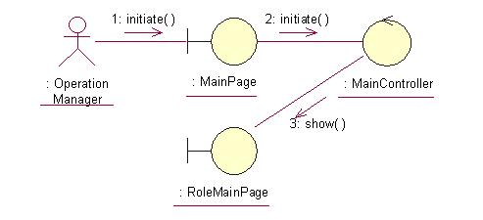
The above collaboration diagram shows the process flow after the actor has login.

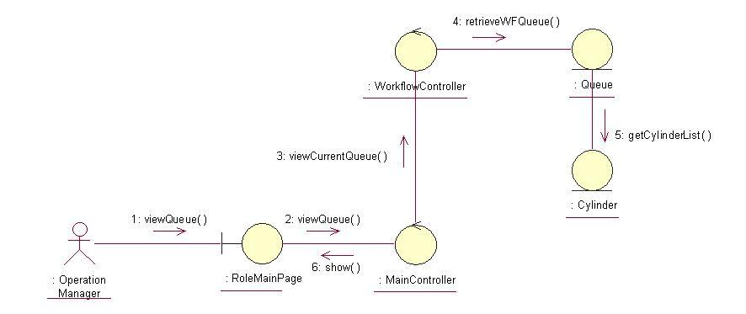
The above collaboration diagram shows the main process flow of this use case.

Participating Objects

Main Page
This object renders the contents after the actor has login. The Director, Department Manager and Operation Manager actors use this object.

Role Main Page
This object renders the contents (based on the user role) after the actor has login. The Director, Department Manager and Operation Manager actors use this object.

Main Controller
This object acts as the middleman between Main Page and the Workflow Controller. It will translate interactions with the view into actions to be performed by the Workflow Controller.

Workflow Controller
This object acts as the middleman between “View Workflow Queues information” Page and the Workflow object. It will translate interactions with the view into actions to be performed by the Workflow, Queue and Cylinder objects.

Queue
This object stores the details concerning the workflow queues information of the COMS.

Cylinder
This object stores the details concerning the cylinder information of the COMS.

Class Diagrams

Domain Class Diagram: View Workflow Queues
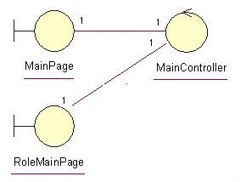
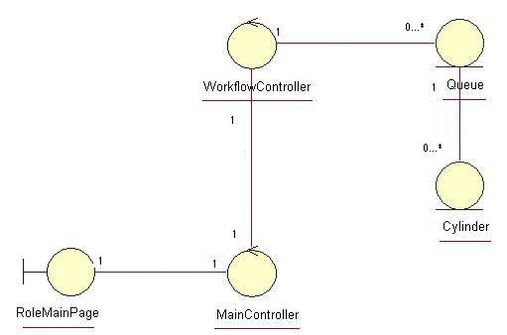

Derived Requirements
The Operation Manager PC keyboard and mouse will be used to retrieve Workflow Queues details (if any) and view all the system responses.

